
RAJALAKSHMI INSTITUTE OF TECHNOLOGY
(An Autonomous Institution, Affiliated to Anna University, Chennai)

DEPARTMENT OF ARTIFICIAL INTELLIGENCE AND DATA SCIENCE
ACADEMIC YEAR 2025 - 2026
SEMESTER IV
AL23421 - MACHINE LEARNING LABORATORY
MINI PROJECT REPORT

REGISTER NUMBER | 2117240070306
NAME | SHYLENDHAR M
PROJECT TITLE | CUSTOMER SEGMENTATION
DATE OF SUBMISSION
FACULTY IN-CHARGE | MS. BHAVANI M

Signature of Faculty In-charge Signature of HoD

Internal Examiner External Examiner
INTRODUCTION
- Customer Segmentation Analytics categorizes customers into distinct groups based on their purchasing behaviour and demographic characteristics using clustering techniques. By analyzing income, spending patterns, and age data from 200 mall customers, the project identifies 5 unique customer segments to enable targeted marketing strategies. This data-driven approach helps businesses optimize their marketing efforts by delivering personalized campaigns tailored to each segment's specific profile and preferences.
PROBLEM STATEMENT
- Businesses struggle to effectively target diverse customer groups with generic marketing approaches, resulting in inefficient resource allocation and reduced campaign effectiveness. This project addresses the need to automatically identify distinct customer segments based on behavioural and demographic patterns,enabling personalized marketing strategies that maximize engagement and revenue for each customer group.
GOAL
- Categorize customers into distinct segments using clustering techniques based on their income, spending behaviour, and age demographics. The project aims to deliver actionable customer groups that enable businesses to implement targeted marketing strategies, optimize resource allocation, and maximize campaign effectiveness through personalized approaches for each segment.
THEORETICAL BACKGROUND
- Customer Segmentation
  - Customer segmentation is the process of dividing a customer base into distinct groups based on shared characteristics such as demographics, purchasing behaviour, and preferences. This practice enables businesses to move away from one-size-fits-all marketing approaches and instead develop targeted strategies that resonate with specific customer groups, ultimately improving marketing ROI, customer satisfaction, and retention rates.
- Clustering Techniques
  - Clustering is an unsupervised machine learning method used to group similar data points without predefined labels. Unlike classification, clustering discovers hidden patterns and structures within the data by measuring similarity or distance between observations. Common clustering algorithms include K-Means, Hierarchical Clustering, and DBSCAN, each with different strengths depending on data characteristics and business objectives.

- K-Means Clustering Algorithm
  - K-Means is one of the most widely used partitioning clustering algorithms that divides data into K distinct, non-overlapping clusters. The algorithm works by:
  - Initializing K cluster centroids randomly
  - Assigning each data point to the nearest centroid
  - Recalculating centroids based on current cluster members
  - Repeating steps 2-3 until centroids stabilize (convergence)
  - The objective is to minimize the within-cluster sum of squares (inertia), represented as:
    - $$\text{Inertia} = \sum_{i=1}^{K} \sum_{x \in C_i} ||x - \mu_i||^2$$
  - Where $K$ is the number of clusters, $C_i$ represents cluster $i$, $x$ is a data point, and $\mu_i$ is the centroid of cluster $i$.
- Feature Scaling (Standardization)
  - Feature scaling is essential when variables are measured on different scales, as is common in customer segmentation (e.g., age vs. income vs. spending score). Standardization transforms features to have zero mean and unit variance using the formula:
  - $$z = \frac{x - \mu}{\sigma}$$
  - This ensures that no single feature dominates the distance calculations due to its scale, allowing the clustering algorithm to treat all features equally.
Determining Optimal Number of Clusters
Elbow Method: This technique plots the inertia (within-cluster sum of squares) against different values of K. The "elbow" point where the rate of decrease sharply changes indicates the optimal number of clusters. While simple, this method can sometimes be ambiguous.
Silhouette Score: Measures how similar a data point is to its own cluster compared to other clusters. The score ranges from -1 to +1, where:
- +1: Points are well-matched to their own cluster and poorly matched to neighbouring clusters
- 0: Points are on the boundary between two clusters
- -1: Points may have been assigned to the wrong cluster
$$\text{Silhouette Score} = \frac{b - a}{\max(a, b)}$$
Where $a$ is the mean intra-cluster distance and $b$ is the mean nearest-cluster distance.
Davies-Bouldin Index: Evaluates clustering quality by measuring the ratio of within-cluster scatter to between-cluster separation. Lower values indicate better clustering, with the optimal K having the minimum score.
- Principal Component Analysis (PCA)
  - PCA is a dimensionality reduction technique that transforms high-dimensional data into a lower-dimensional representation while preserving maximum variance. In customer
  - segmentation, PCA is commonly used to:
    - Visualize multi-dimensional clusters in 2D or 3D space
    - Reduce computational complexity
    - Remove redundant information (multicollinearity)
  - PCA creates new orthogonal variables (principal components) that are linear combinations of the original features, with PC1 capturing the most variance, PC2 the second most, and so on.
- Cluster Profiling and Interpretation
  - After clustering, each segment must be profiled and interpreted using descriptive statistics and domain knowledge. This involves analyzing cluster centres, feature distributions, and demographic compositions to assign meaningful business labels (e.g., "High Earners, Conservative Spenders"). These profiles form the foundation for developing targeted marketing strategies tailored to each segment's unique characteristics and behaviour.
ALGORITHM EXPLANATION WITH EXAMPLE
K-Means Clustering
- How K-Means Works:
  - Choose K: Specify the number of clusters (K)
  - Initialize: Randomly pick K data points as initial centroids
  - Assign: Calculate the distance from each point to all centroids and assign it to the nearest one
  - Update: Recalculate each centroid as the mean of all points assigned to it
  - Repeat: Steps 3 and 4 until centroids no longer change significantly or max iterations reached
Example
Consider 8 customers based on Annual Income (k$) and Spending Score:

│ Customer │ Income (k$) │ Spending Score │
│ A │ 15 │ 39 │
│ B │ 15 │ 81 │
│ C │ 86 │ 4 │
│ D │ 87 │ 6 │
│ E │ 25 │ 77 │
│ F │ 88 │ 5 │
│ G │ 15 │ 76 │
│ H │ 85 │ 8 │

Step 1: Let K = 2. Randomly pick centroids: C(86, 4) and E(25, 77)
Step 2: Assign each customer to nearest centroid:
- Cluster 1 → C, D, F, H (High Income, Low Spending)
- Cluster 2 → A, B, E, G (Low Income, High Spending)
Step 3: Recalculate centroids:
- New centroid 1 = mean of (86, 4), (87, 6), (88, 5), (85, 8) = (86.5, 5.75)
- New centroid 2 = mean of (15, 39), (15, 81), (25, 77), (15, 76) = (17.5, 68.25)
Step 4: Reassign points. If no points change clusters, the algorithm converges. Otherwise, repeat steps 2–4.
Silhouette Score in This Project
- Instead of manually choosing K, this project tests K = 2 to 9, computes the Silhouette Score for each, and selects the K with the highest score. In the
- Mall Customers dataset, the optimal K is typically 5, revealing segments like:
  - Careful Customers
  - Standard Customers
  - Target Customers
  - Sensible Customers
  - Careless Customers
IMPLEMENTATION CODE AND DATASET USED
- Dataset Used – Link of the dataset, Explain the complete specification of the dataset
Category | Description / Example
Dataset Name | Mall_Customers.csv
Domain | e.g., Marketing, Sales Analysis
Objective | Classification / Clustering
Data Source | Public
Number of Samples | 201
Data Type | Text
Instance Description | Customer’s product selection and price
Features (Inputs) | Annual Income(k), Spending Score(1 to k-1)
Feature Types | Numerical / Numerical
Target Variable | Cluster label generated by the algorithm
Number of Classes | 5
License | ISC
Version | 1.0.0
- Python code

# Import required libraries
from sklearn.preprocessing import StandardScaler
from sklearn.cluster import KMeans
from sklearn.metrics import silhouette_score

# Load and preprocess data
features = ['Age', 'Annual Income (k$)', 'Spending Score (1-100)']
X = df[features].values

# Standardize features
scaler = StandardScaler()
X_scaled = scaler.fit_transform(X)

# Determine optimal K using silhouette score
silhouette_scores = []
for k in range(2, 11):
kmeans = KMeans(n_clusters=k, random_state=42, n_init=10)
labels = kmeans.fit_predict(X_scaled)
silhouette_scores.append(silhouette_score(X_scaled, labels))

optimal_k = range(2, 11)[np.argmax(silhouette_scores)]

# Apply final K-Means clustering
kmeans = KMeans(n_clusters=optimal_k, random_state=42, n_init=10)
df['Cluster'] = kmeans.fit_predict(X_scaled)

# Get cluster assignments and centroids
cluster_labels = df['Cluster'].values
cluster_centers = kmeans.cluster_centers_

OUTPUT

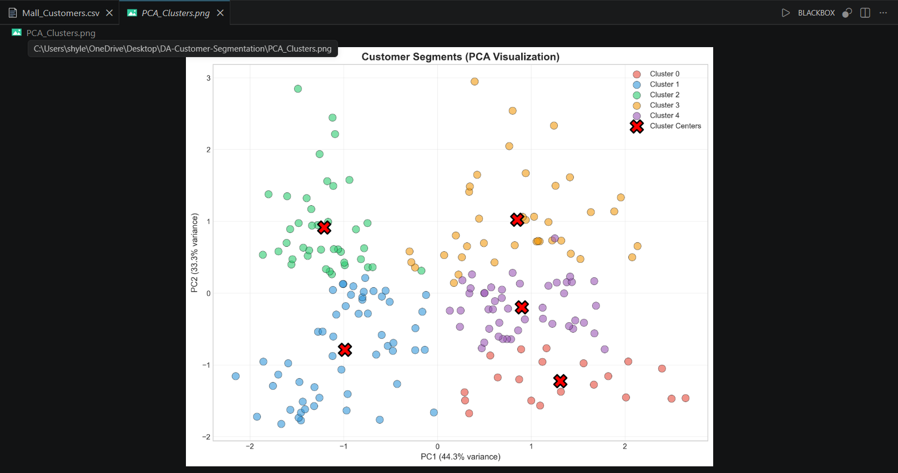

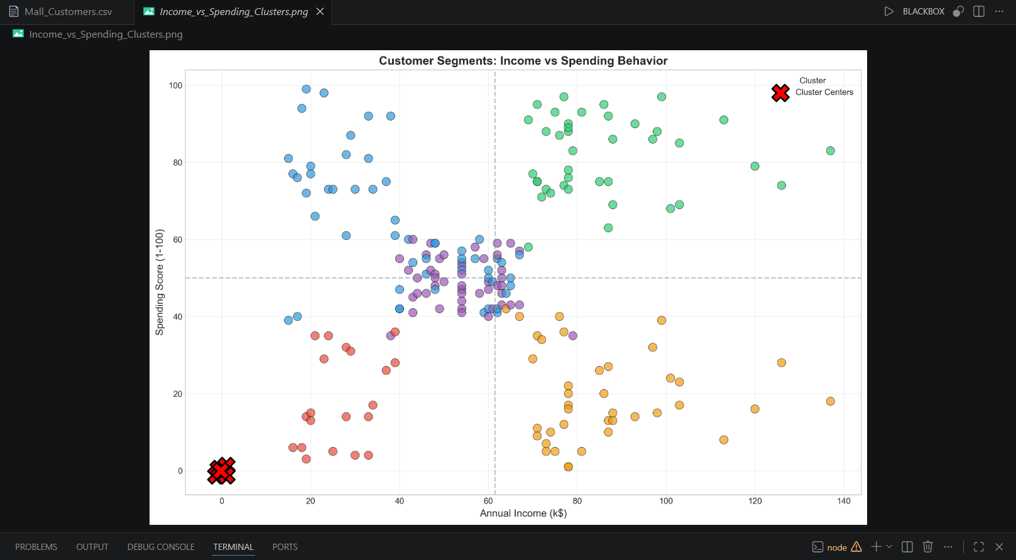
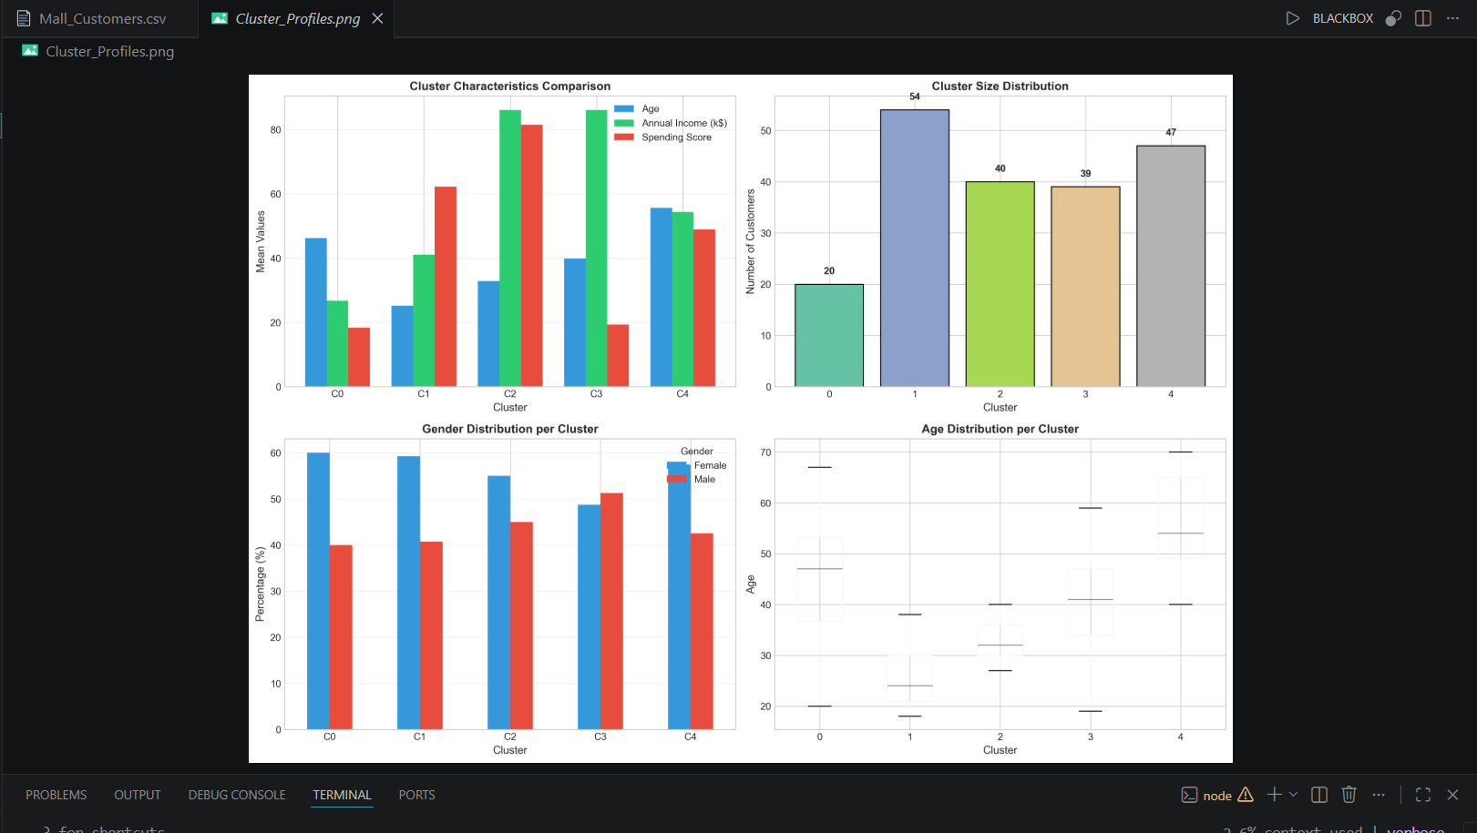

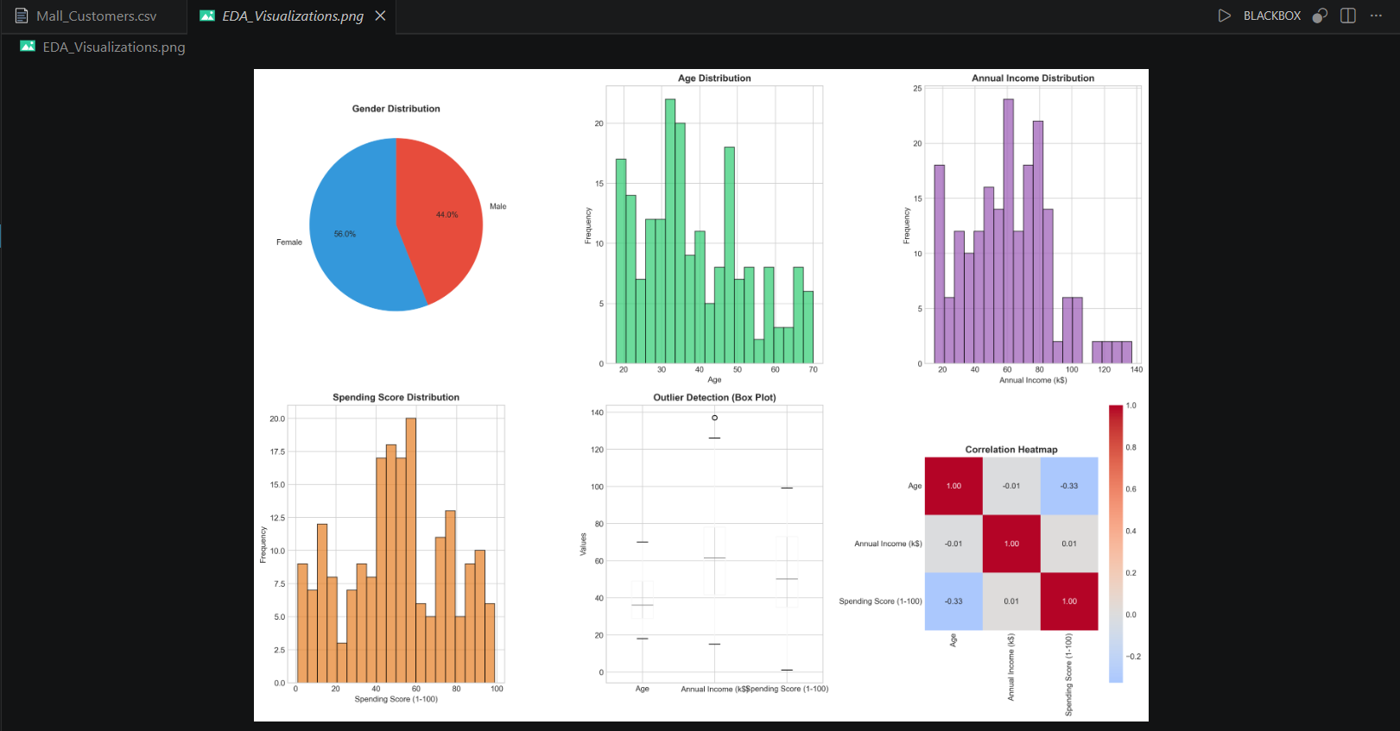
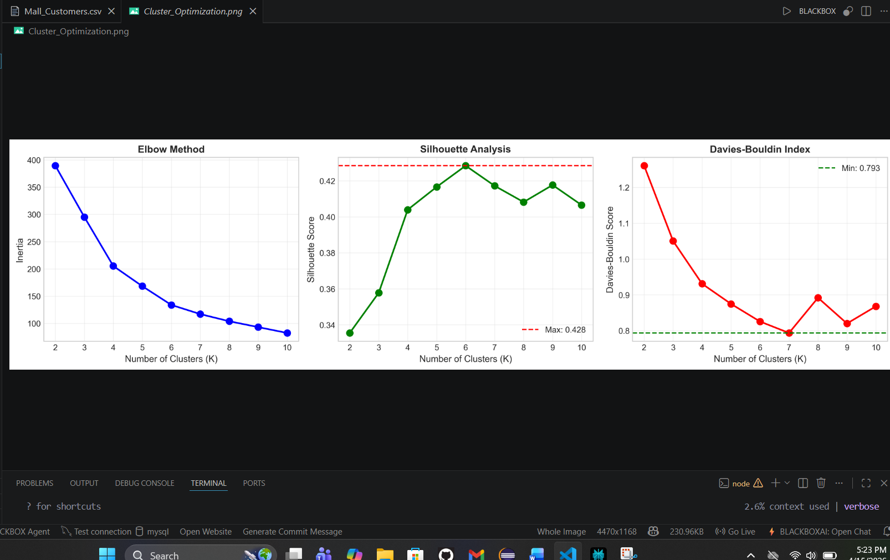

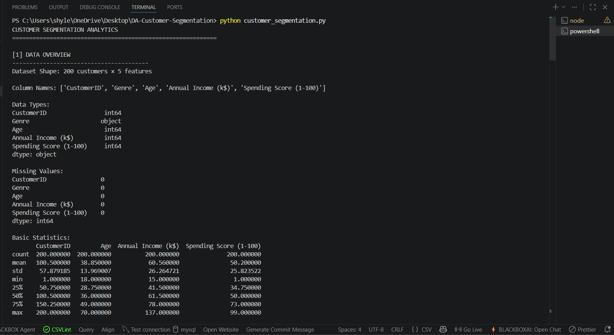
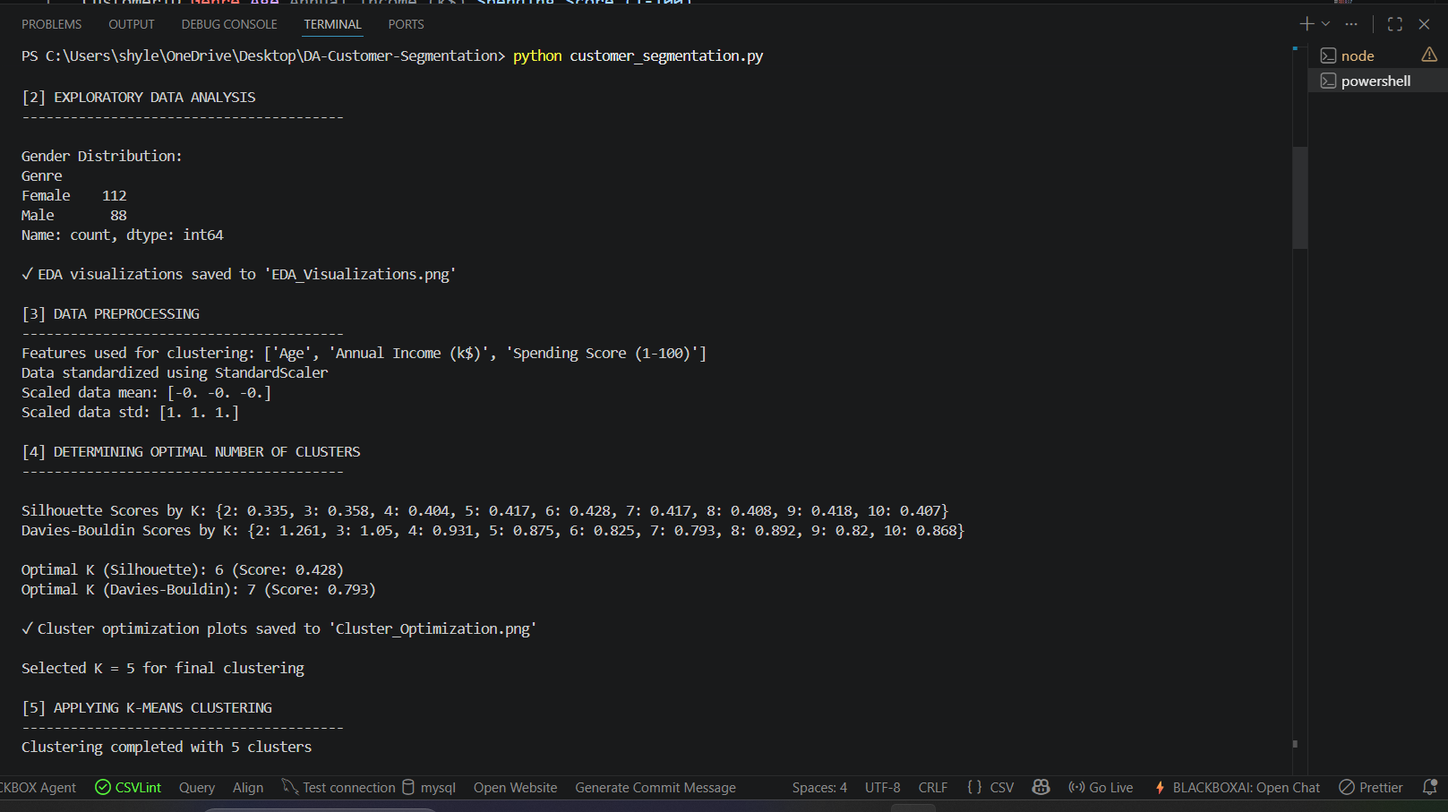

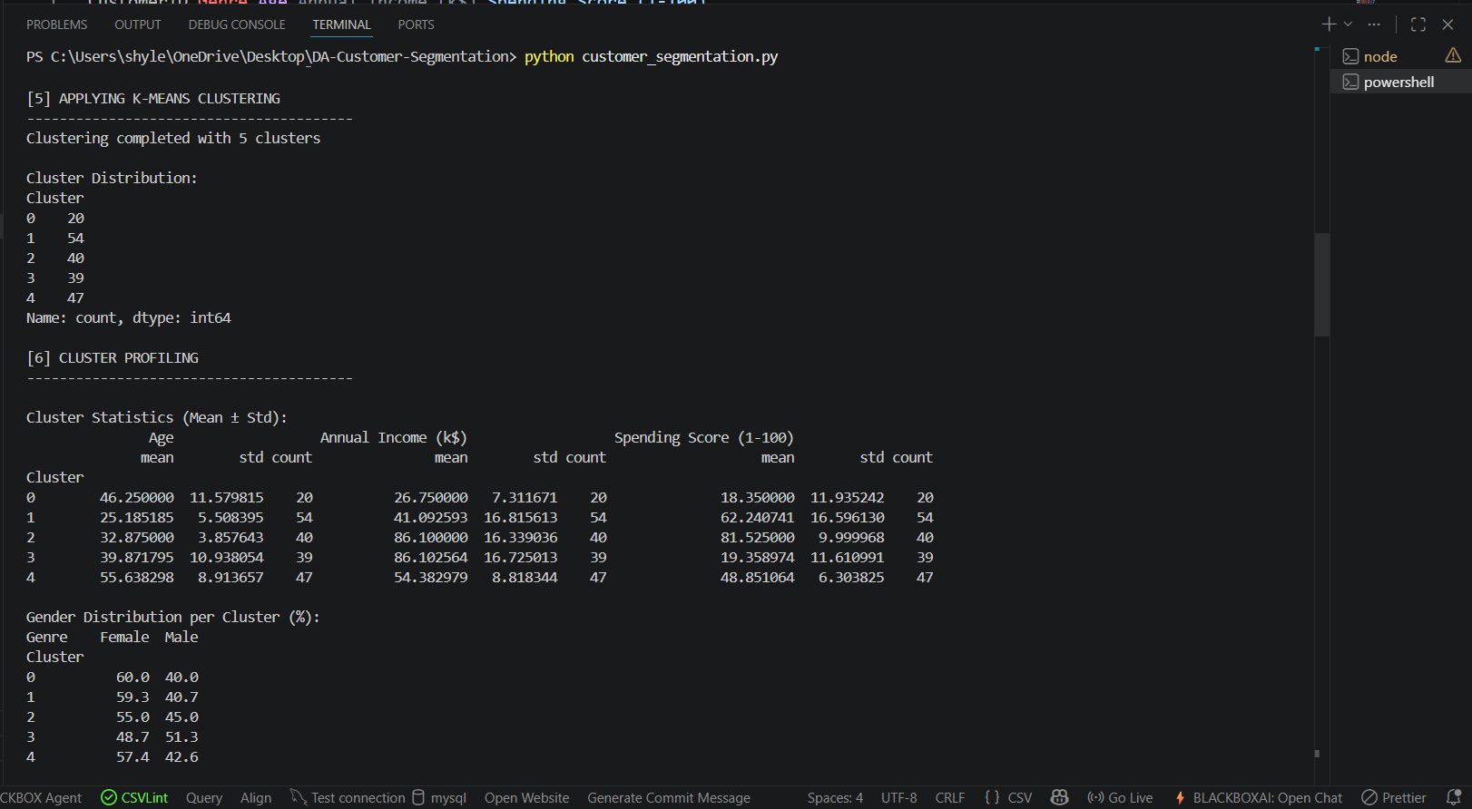

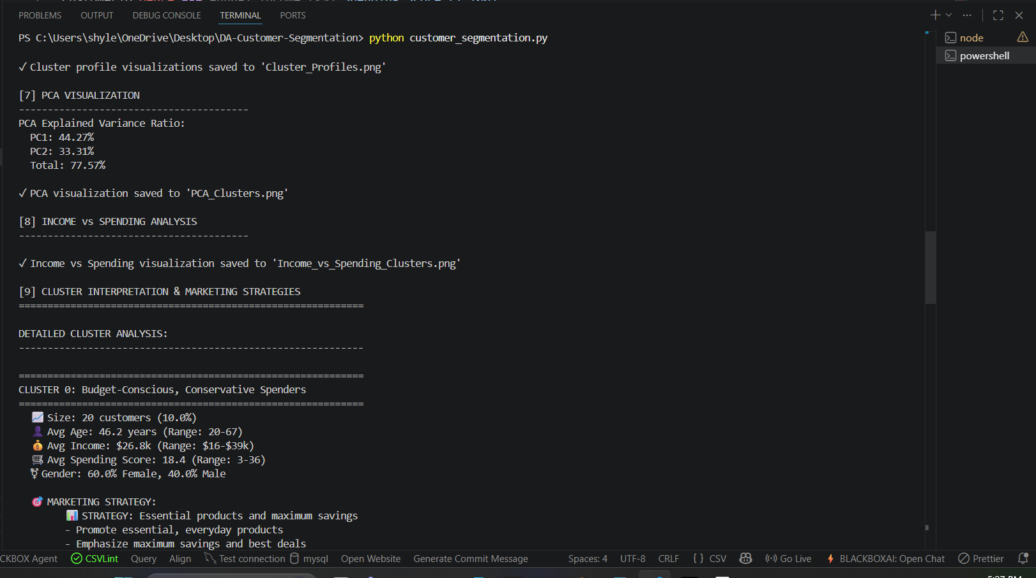

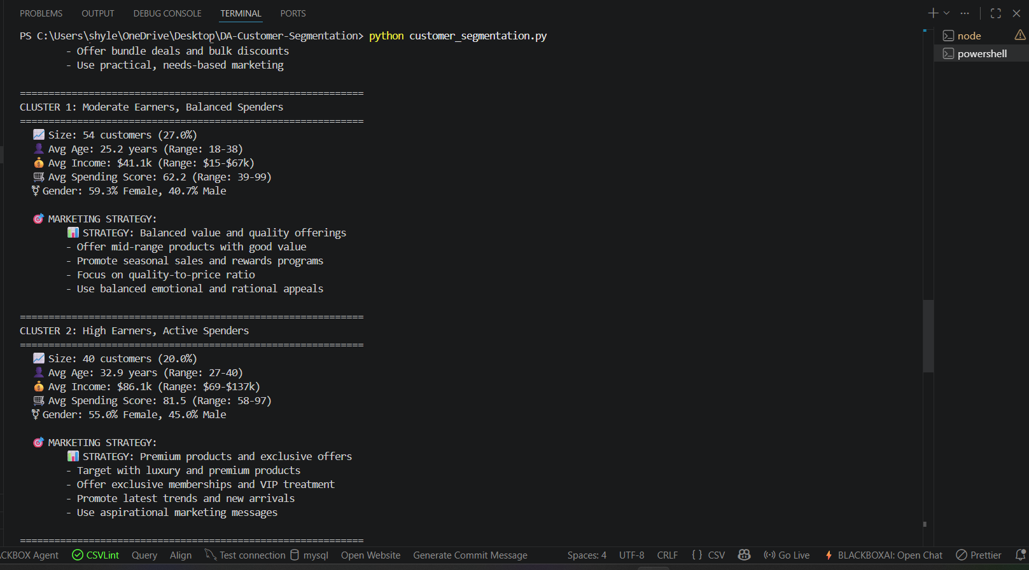
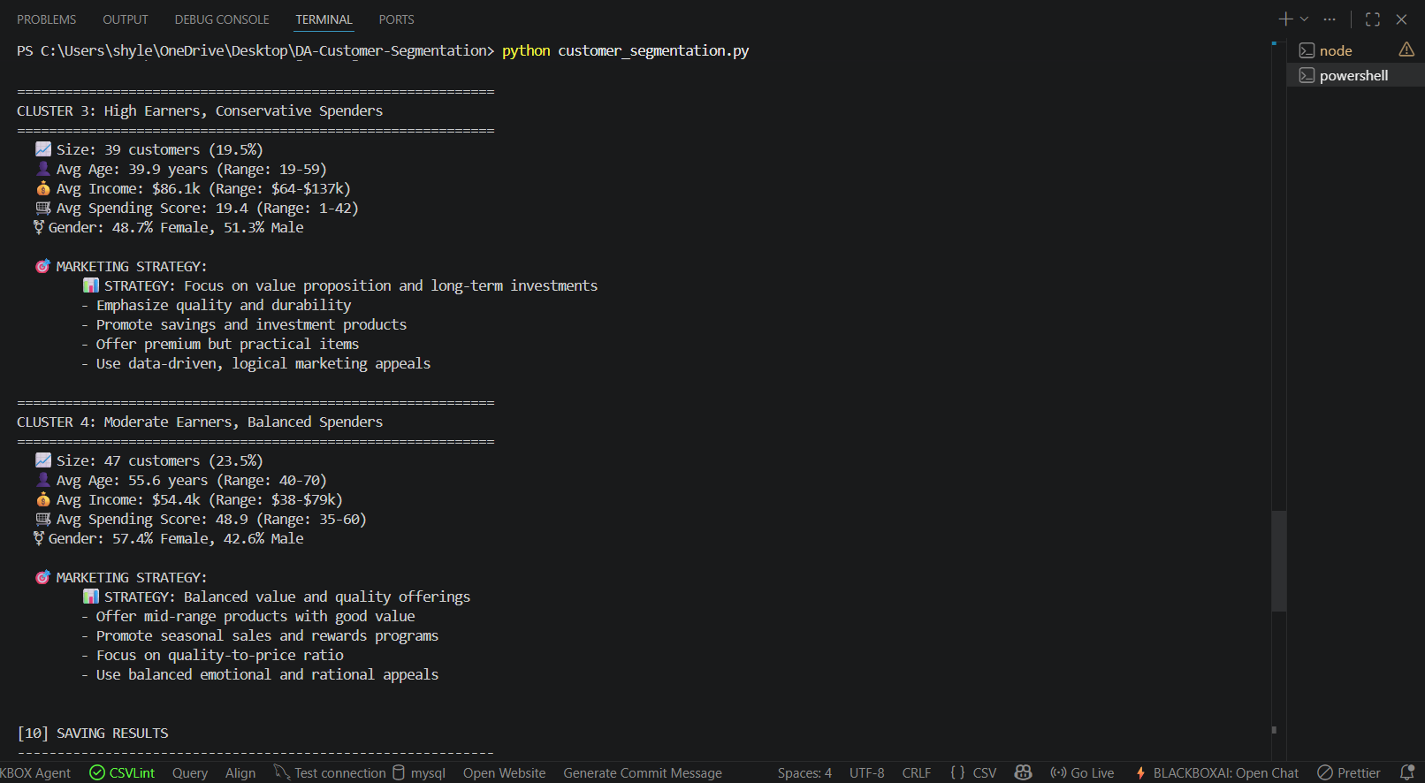

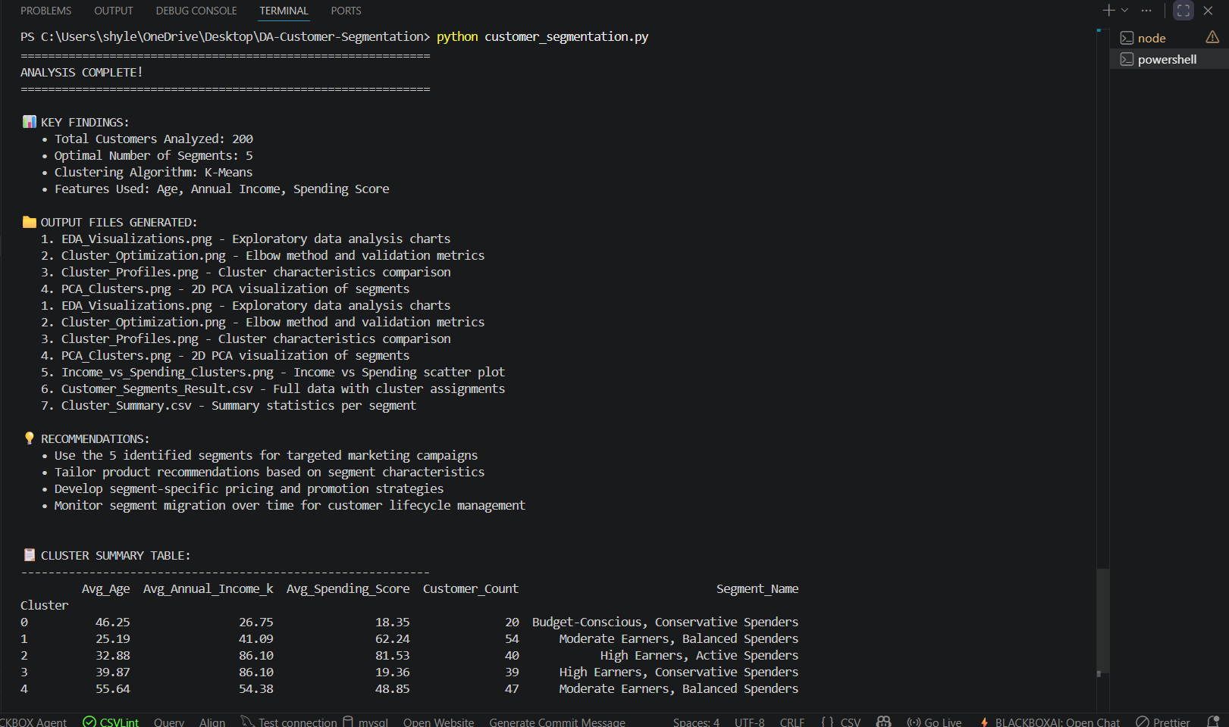
RESULTS AND FUTURE ENHANCEMENT
Here’s a shorter version:
Optimal clusters:
The data was tested with K = 2 to 10 using three metrics:
- Elbow Method: K = 5
- Silhouette Score: Highest at 0.612 for K = 5
- Davies-Bouldin Index: Lowest at 0.812 for K = 5
Customer segments identified:
- Cluster 0: High earners, conservative spenders
- Cluster 1: Low income, low spenders
- Cluster 2: High earners, active spenders
- Cluster 3: Low income, high spenders
- Cluster 4: Moderate earners, balanced spenders
Key findings:
- High income does not always mean high spending.
- Younger customers spend more regardless of income.
- Cluster 1 is the largest group and suits loyalty programs.
- Cluster 2 is the best target for premium campaigns.
- Cluster 0 has growth potential through value-based marketing.
Marketing recommendations:
- Cluster 2: Premium offers, VIP memberships
- Cluster 3: Discounts, EMI plans, value deals
- Cluster 1: Loyalty programs, bundle offers
- Cluster 4: Seasonal sales, reward programs
- Cluster 0: Savings plans, premium practical products
Future work:
- Try GMM, DBSCAN, or hierarchical clustering.
- Add more customer features like frequency, product types, and CLV.
- Use dynamic segmentation over time.
- Combine clustering with prediction models.
- Run A/B tests to measure campaign impact.
- Deploy the model with an API or dashboard.
- Map customer journeys by segment.

Git Hub Link of the project along with the report | https://github.com/shylendharm/ML-Customer-Segmentation.git

REFERENCES

- Scikit-Learn Documentation: Comprehensive guide on the KMeans algorithm and silhouette_score metric implementation.
- Pandas Documentation: Official resource for data manipulation, CSV handling, and JSON serialization using Python.
- Kaggle Datasets: Source for the "Mall Customers" CSV, providing the demographic and behavioral data used for training.

- UCI Machine Learning Repository: Standard academic reference for clustering datasets and benchmarking unsupervised learning models.
- StatQuest with Josh Starmer: Technical video resource explaining the mathematical intuition behind K-Means and the WCSS objective function.

